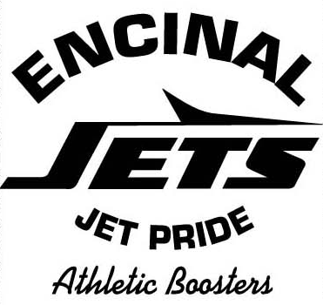

ENCINAL HIGH SCHOOL ALUMNI ASSOCIATION (EHSAA)

EHS ATHLETIC HALL OF FAME CHAIRPERSON

and COMMITTEE

DUTIES and REPONSIBILITIES

CHAIRPERSON:

- Leads the planning, organization, coordination, promotion, and execution of EHS Athletic Hall of Fame Induction Ceremonies every other year

- Oversees the development of an EHS Athletic Hall of Fame Committee for purposes of maintaining the EHS HoF school display and records, the HoF induction process, and HoF induction ceremonies; and, coordinates related EHS and EHSAA events

- Oversees the committee review of all nominations received, develops and adheres to fair and non-biased selection criteria, and maintains the integrity of fair and impartial review and selection processes

- Provides EHSAA membership HoF information at EHSAA Board Meetings and as requested by the EHSAA Board

- Solicits the EHSAA Board and General Membership support for events

- Makes projections for related HoF expenditures, maintains appropriate financial documentation of EHS Athletic HoF activities and presents to the EHSAA Treasurer, and make recommendations for the use of fundraising income

- Leads or supports the annual EHSAA Student Athlete Scholarship application, review and award process

- Meetings – as determined.

COMMITTEE MEMBERS

- Supports the planning, organization, coordination, promotion, and execution of EHS Athletic Hall of Fame Induction Ceremonies every other year

- Supports the maintenance of the EHS HoF school display and records, the HoF induction process, HoF induction ceremonies, and coordination of related EHS and EHSAA events

- Solicits nominations of EHS graduates for induction into the EHS Athletic Hall of Fame

- Reviews all nominations received, adheres to fair and non-biased selection criteria, and maintains the integrity of fair and impartial review and selection processes

- Leads or supports the annual EHSAA Student Athlete Scholarship application, review and award process

- Attends all related HoF and EHSAA meetings, as determined.

