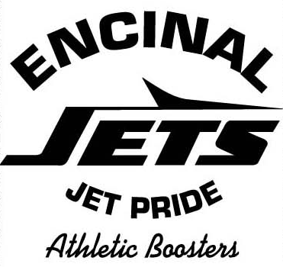

ENCINAL HIGH SCHOOL ALUMNI ASSOCIATION (EHSAA)

EHS GOLF TOURNAMENT

CHAIRPERSON and COMMITTEE

DUTIES and REPONSIBILITIES

CHAIRPERSON:

- Leads the planning, organization, coordination, promotion, and execution of the annual EHS Golf Tournament

- Oversees the development of an EHS Golf Tournament Committee for purposes of supporting annual events and other related EHS and EHSAA events

- Provides EHSAA membership Golf Tournament information at EHSAA Board Meetings and as requested by the EHSAA Board

- Solicits the EHSAA Board and General Membership support for events

- Makes projections for related Golf Tournament expenditures, maintains appropriate financial documentation of related activities and presents to the EHSAA Treasurer, and makes recommendations for the use of fundraising income

- Meetings – as determined.

COMMITTEE MEMBERS

- Supports the planning, organization, coordination, promotion, and execution of the annual EHS Golf Tournament

- Supports the coordination of related EHS and EHSAA events

- Supports the maintenance of appropriate financial documentation of related activities and presentation to the EHSAA Treasurer, and makes recommendations and final; decisions for the use of fundraising income

- Attends all related EHSAA meetings, as determined.

